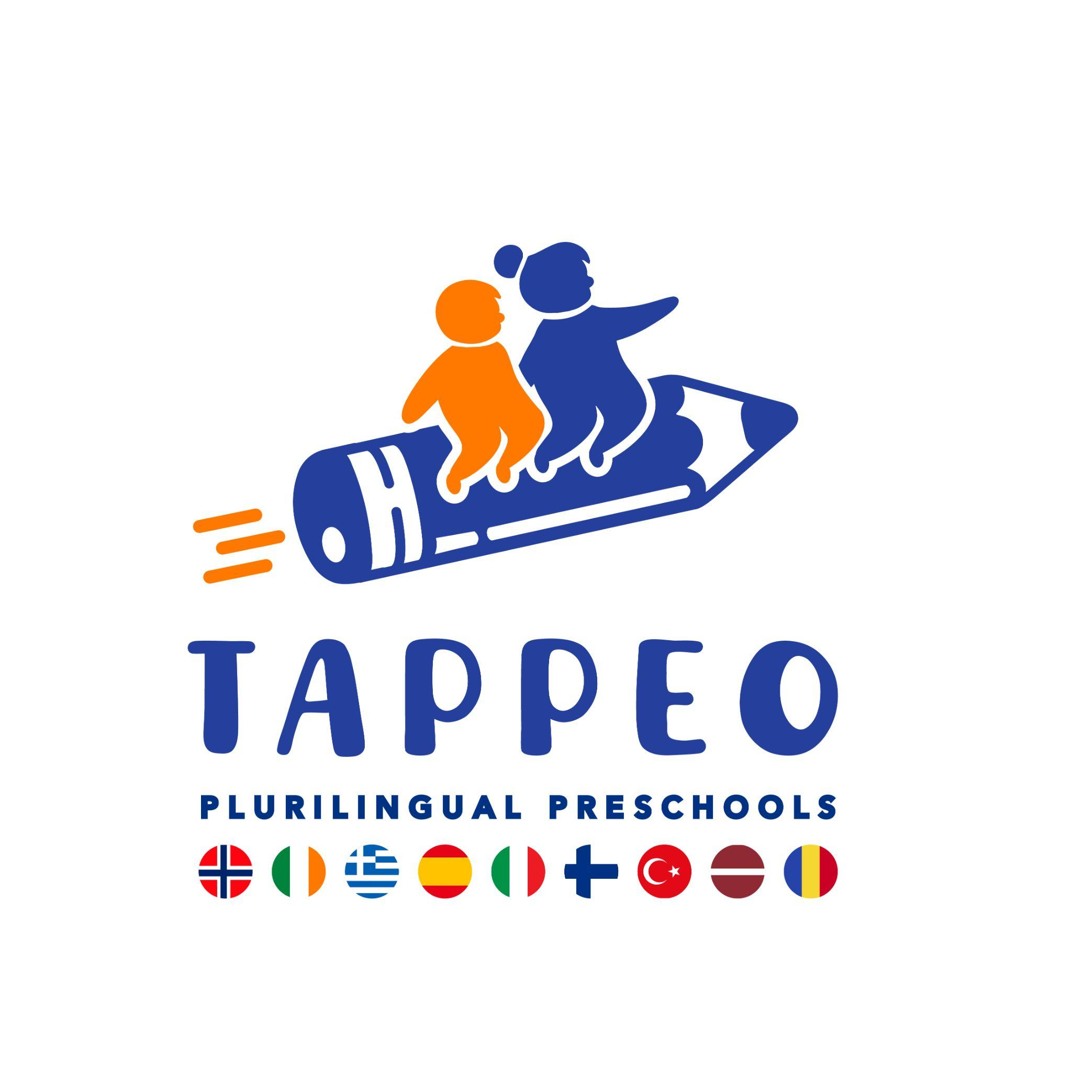
Project Report

TAPPEO FACE-TO-FACE TEACHER TRAINING PROGRAMME FINAL REPORT

Teacher Training Workshops and Seminar
on Immersive Language Experiences for Young Learners

Ankara, 11–12 December 2025

 Funded by the European Union. Views and opinions expressed are however those of the author(s) only and do not necessarily reflect those of the European Union or the European Education and Culture Executive Agency (EACEA). Neither the European Union nor EACEA can be held responsible for them. Project No.: 101196622

Project Partners
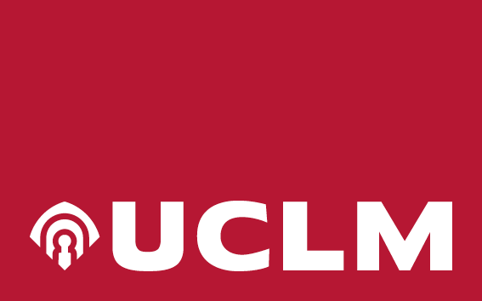 | 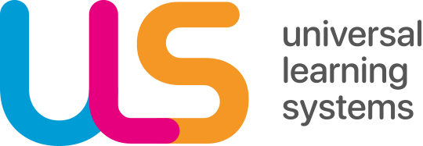
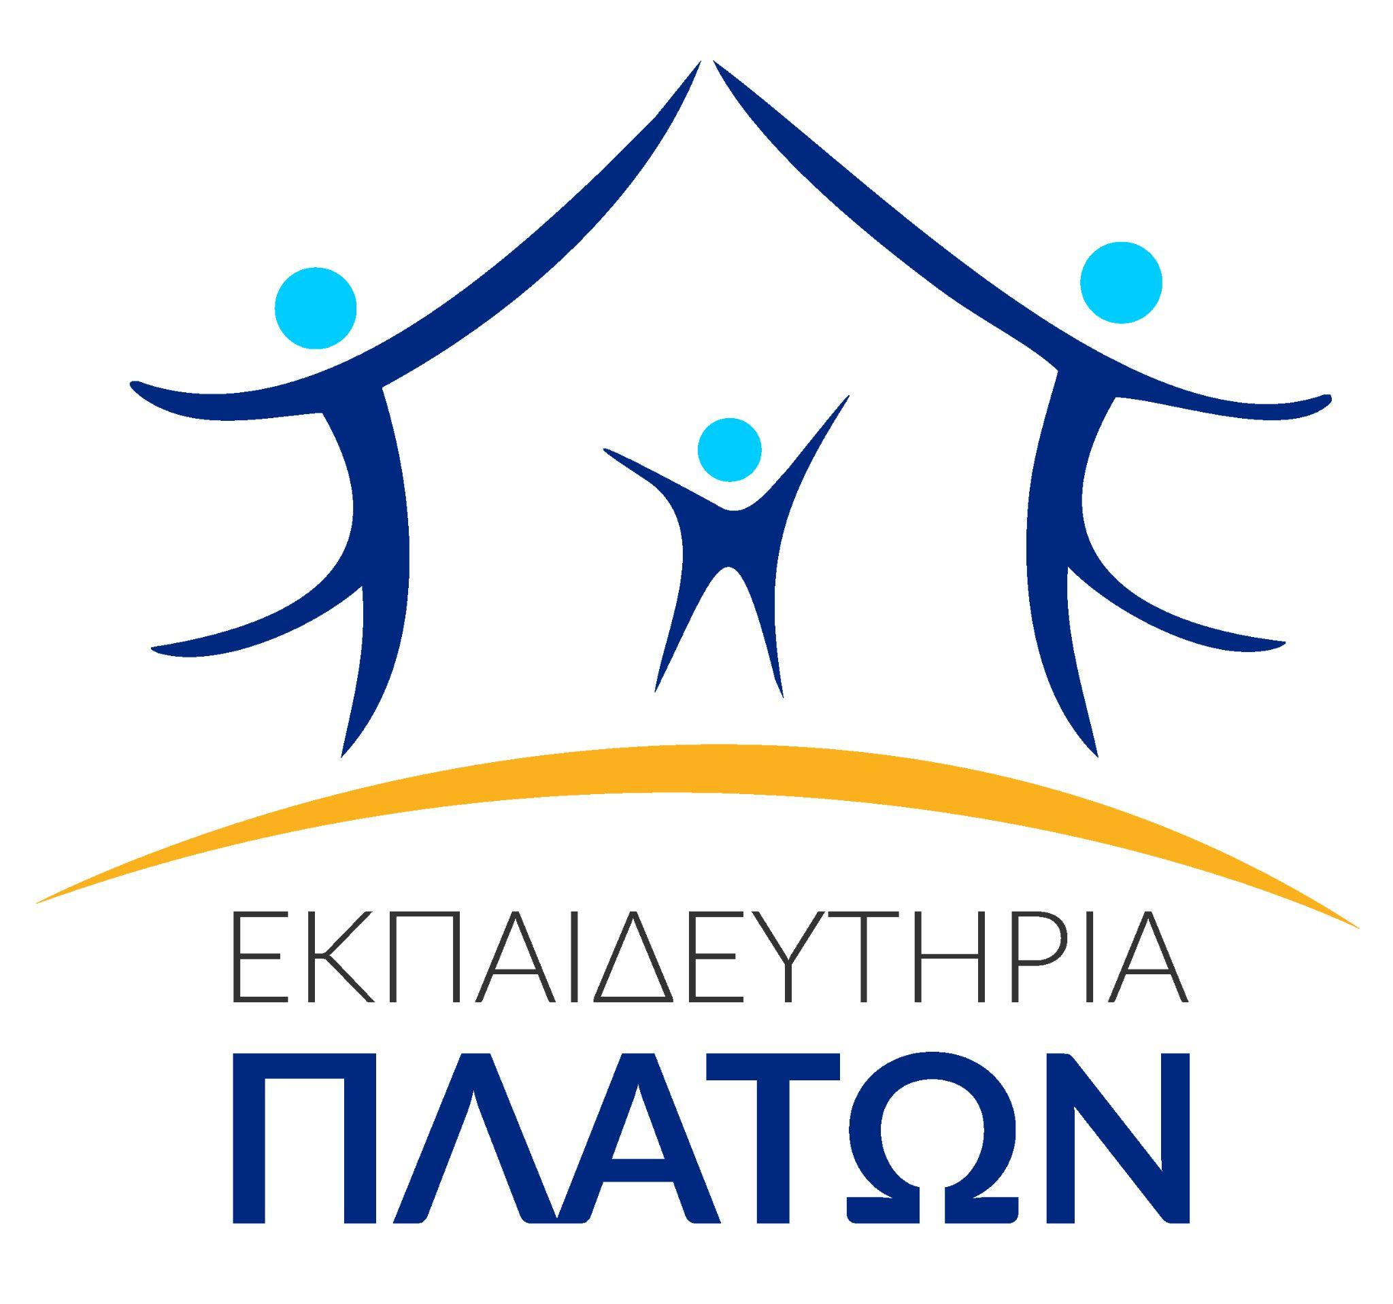 | 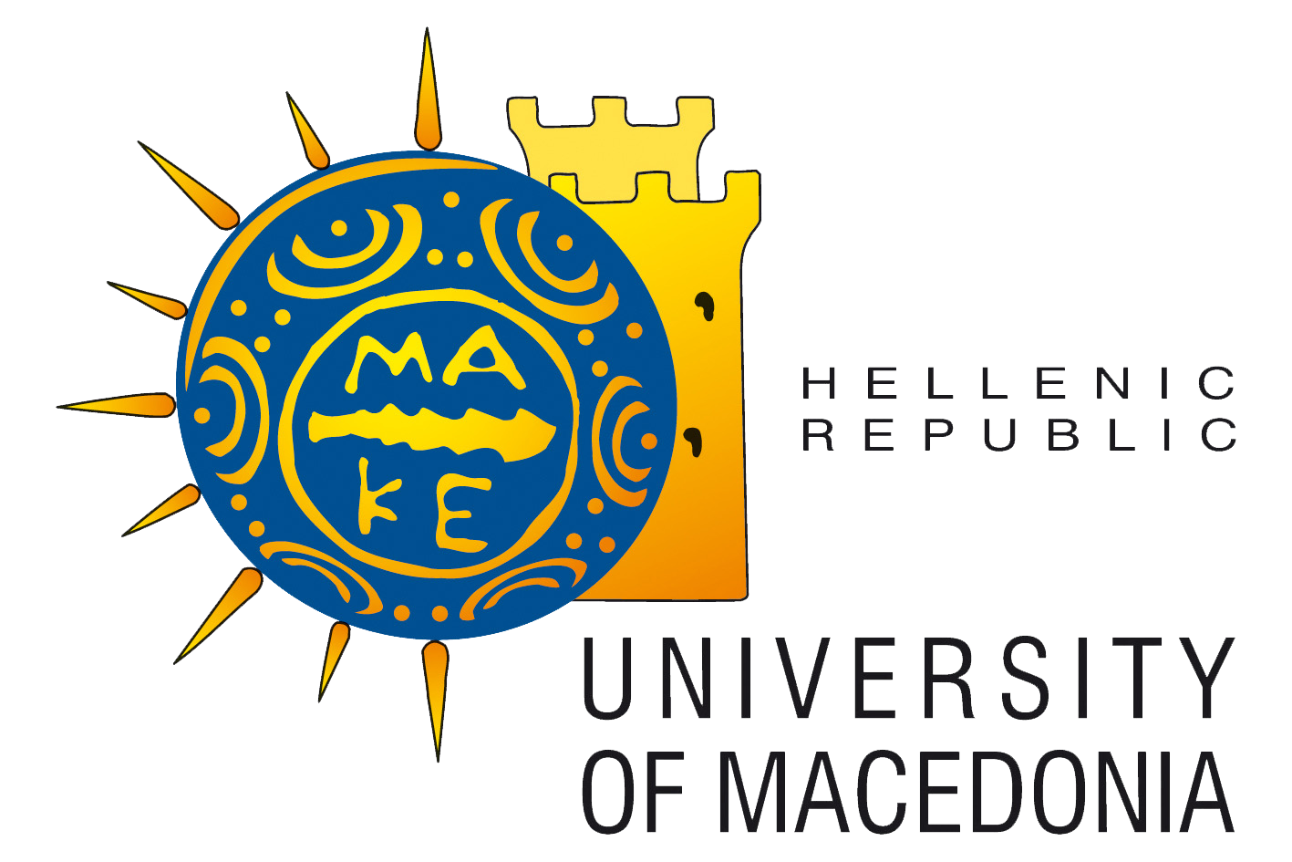
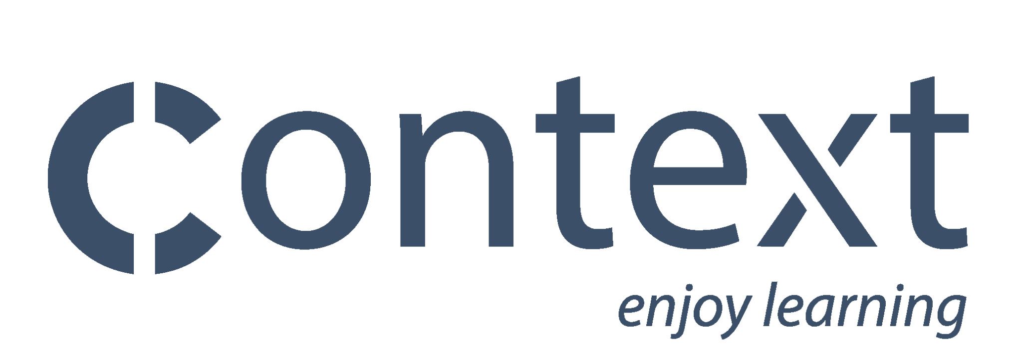 | 
 | 
 | 

Document Details
Project Title: | Teacher Academy for Plurilingual Preschools. A Path Towards Equal Opportunities
Acronym: | TAPPEO
Call: | ERASMUS-EDU-2024-PEX-TEACH-ACA
Project Number: | 101196622
Start Date: | April 2025
Duration: | 36 months
Authors: | Berna Aslan, Cengiz Aslan, Asuman Fulya Soğuksu, Özlem Kanat, Kader Karadeniz Akdoğan, Gökçe Adıbelli
Contributors: | UCLM, ULS, Platon Schools
Visibility: | Public Document
Date: | May 2026

Project Team
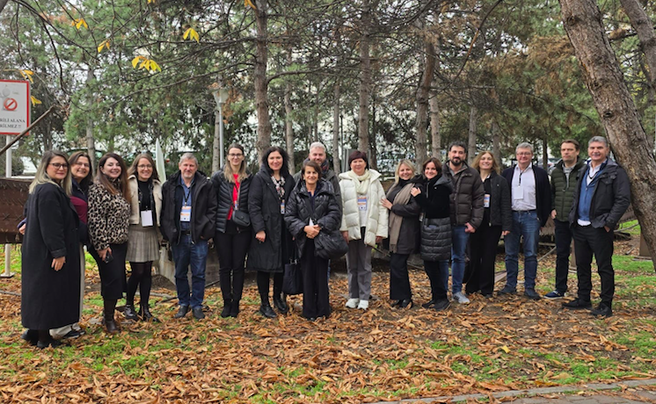

Table of Contents
Project Partners 2
Document Details 3
Project Team 3
1. Introduction 5
2. Pedagogical Framework and Content Selection 6
2.1. Professional Learning Design 6
2.1.1. Practice-based professional learning 6
2.1.2. Reflective Professional Learning 7
2.1.3. Collaborative Professional Learning 7
2.1.4. Conceptual Deepening 7
2.1.5. Linguistic Accessibility and Plurilingual Learning Environment 8
2.2. Content selection 8
2.2.1. Theoretical content of the teacher training 8
2.2.2. Pedagogical approaches and methods in the teacher training 9
2.2.3. Pedagogical production processes in the teacher training 9
3. Learning Outcomes 10
4. Overview of the Teacher Training Programme 13
5. Description of the Teacher Training Activities 14
6. Evaluation of the Teacher Training 29
6.1. Evaluation design and instrument 29
6.2. Participants 29
6.3. Evaluation results 32
6.3.1. Overall satisfaction 32
6.3.2. Sense of professional self-Efficacy 33
6.3.3. Learning Experiences 34
6.3.4. Future Learning Needs 35
7. Conclusion 36
8. References 37

1. Introduction
Teacher Academy for Plurilingual Preschools. A Path towards Equal Opportunities (TAPPEO) project aims to promote plurilingualism among young learners and foster inclusive learning environments. The project focuses on developing teachers’ and teacher candidates’ professional competencies to support young learners in classrooms with linguistic and cultural diversity. The goal is to provide teachers with advanced knowledge and skills in innovative pedagogical approaches such as content and language integrated learning (CLIL), immersive language experiences and culturally responsive teaching.

In Europe, inclusive and high-quality early childhood education systems play a critical role in ensuring equal opportunities in education (European Commission, 2025). The lifelong effects of educational inequality can emerge in early childhood and significantly impact a child’s learning and development opportunities. Early childhood education policies are considered important in reducing educational disparities through strategies that strengthen equality in both access and quality (OECD, 2025). In recent years, due to the impact of migration and demographic change, linguistic and cultural diversity in early childhood education settings in Europe has increased significantly. The rise in the number of children whose first language differs from the language of instruction necessitates a rethinking of pedagogical approaches in early childhood education institutions. Among the quality indicators in early childhood education, teacher competencies and continuous professional development occupy a central position. On the other hand, in many educational systems in Europe, teachers’ systematic preparation for multilingual and culturally diverse classroom environments is limited (European Commission, 2023). In this context, teacher education programmes that support inclusive practices based on plurilingual pedagogies are emerging as a strategic necessity for ensuring equal opportunities in early childhood education.

As part of the project’s third work package, teacher training sessions were designed and implemented to support the language development and educational participation of children from migrant backgrounds or whose first language differs from the language of instruction. The main goal of these training sessions was to provide teachers with the necessary theoretical framework, pedagogical strategies, and concrete teaching tools to develop inclusive and equitable practices in plurilingual classrooms. In line with the objectives of the work package, the two-day face-to-face teacher training programme was structured around the theme “Immersive Language Experiences for Young Learners.”

Teacher training sessions were held at Ankara University’s Central Campus on 11–12 December 2025 with 178 participants in total. The programme consisted of six training activities, including five workshops and one seminar, which were conducted in parallel sessions. The workshops were practice-based, supporting participants in learning through experience and collaboration, and in developing adaptations for their own classroom contexts. The seminar focused on parental engagement in plurilingual classrooms. The training sessions were led by academics and educators from various partner institutions.

The target group for the training consisted of teachers and teacher candidates. A significant number of participants were teacher candidates enrolled in various undergraduate programmes at Ankara University Faculty of Educational Sciences, while teachers from different countries participating in the project were also included in the programme. This multicultural and multilingual participant profile created a learning environment that directly corresponded with the content of the training and allowed participants to share experiences from different countries and classroom contexts.

This report first presents the pedagogical framework and content selection criteria on which teacher training is based. It then discusses the general and workshop/seminar-based learning outcomes, provides an overview of the training schedule, and details the activities carried out in the workshops. Finally, the evaluation results are shared and the report concludes with future implications and recommendations.

2. Pedagogical Framework and Content Selection

2.1. Professional Learning Design
According to Darling-Hammond and Oakes (2019), in order for teachers to support diverse groups of learners in a fair and inclusive manner, both pre- and in-service professional learning processes must be supported by practice-based, reflective, and collaborative activities. The present workshops and seminars designed in line with this approach bring together practice-based, reflective, and collaborative professional learning components within a coherent framework.

2.1.1. Practice-based professional learning
In line with the practice-based teacher education approach, the professional development of teachers and teacher candidates is achieved not only by acquiring pedagogical knowledge at a conceptual level but also by experiencing pedagogical practices in structured and supported learning environments (Grossman, Hammerness & McDonald, 2009). In this regard, the training sessions were designed as a practice-based professional learning environment that goes beyond participants’ acquisition of theoretical knowledge and enables them to directly develop their practical skills. In each session, participants actively engaged in production processes such as designing activities for plurilingual classrooms, developing applicable teaching scenarios for the classroom, and adapting existing materials. This approach draws on the understanding that teacher learning is strengthened through activities close to classroom reality and involving authentic pedagogical decision-making processes. Therefore, the workshops aimed to bridge the gap between theory and practice and enable participants to produce practical outputs that they could transfer to their own teaching contexts.
For teachers, this design has enabled them to reflect on existing classroom practices, to expand their pedagogical repertoire for teaching in plurilingual classrooms, and to reinterpret their experiences within a theoretical framework. For teacher candidates, the training contributed to building their emerging professional identities from a plurilingual and inclusive perspective, strengthening their pre-service pedagogical preparation, and gaining experience based on real classroom scenarios. In this respect, the teacher training created a complementary and multi-layered professional learning environment for participants with different levels of experience.

2.1.2. Reflective Professional Learning
Reflective thinking is seen as one of the fundamental elements of professional learning and enables teachers to develop their pedagogical reasoning by critically analyzing their experiences (Zeichner & Liston, 1996). On this basis, reflective thinking has been placed at the center of professional learning in the design of the present training. Participants were provided with both individual and collective reflection opportunities. The individual reflection process was supported through structured reflective forms used in all training sessions. These forms enabled participants to evaluate the workshop content in the context of their own teaching understanding, perceptions of plurilingualism, and classroom practices. This allowed them to identify their strengths and areas for development. Thus, reflection was treated not only as an end-of-activity feedback tool but also as a systematic learning component that deepened pedagogical reasoning.
Collective reflection was structured by the facilitator in a manner specific to the content of each session and was conducted as an integral part of the training process. During this process, participants discussed the practices they had engaged in together, shared examples from different classroom contexts, and jointly evaluated their pedagogical decisions regarding plurilingual environments. The presence of both teachers and teacher candidates made the reflection processes multi-layered. Joint reflection provided a learning space that strengthened not only individual awareness but also the shared production of professional sense-making.

2.1.3. Collaborative Professional Learning
Collaborative interactions, experience sharing, and joint problem-solving processes in teachers’ professional learning processes are among the fundamental components that support the development of pedagogical knowledge and practices (Vescio et al., 2008). In this regard, the present training sessions have been designed as collaborative learning environments where participants can share their knowledge and experiences with each other. Through small group work and collaborative production processes, participants designed activities together, discussed pedagogical approaches to plurilingual classrooms, and evaluated the difficulties encountered in different classroom contexts.
The presence of both teachers and teacher candidates made these collaborative processes multifaceted. The experience-based knowledge and practice examples of teachers with different levels of professional experience interacted with the theoretical perspectives and current pedagogical approaches of the teacher candidates. Furthermore, the sharing of experiences related to classroom practices among participants from different countries and education systems has made it clear that the issues of plurilingualism and inclusion are not limited to a single national context. These interactions have increased awareness of the contextual nature of pedagogical decisions and strengthened collective sense-making.

2.1.4. Conceptual Deepening
The seminar session was designed as a complementary structure to the practice-based workshops. While the workshops focused on developing pedagogical practices, the seminar addressed macro-level issues such as parental engagement, school-family cooperation, and inclusive education policies in plurilingual early childhood settings by providing a broader contextual framework. In this way, the seminar enabled participants to evaluate classroom practices within a broader socio-cultural and institutional context, revealing that pedagogical decisions have not only technical but also ethical and social dimensions. Thus, the programme offered a balanced structure between practice development and theoretical and contextual deepening.

2.1.5. Linguistic Accessibility and Plurilingual Learning Environment
The training sessions aimed to go beyond addressing plurilingualism at the content level and to structure the learning environment itself in a linguistically inclusive manner. Sessions were conducted bilingually in Turkish and English or with translation support. Participants were encouraged to engage in discussions and production processes without experiencing language barriers. This approach created a learning environment where multilingual pedagogies were not only discussed theoretically but also experienced. Thus, the programme concretized the principles of linguistic equality and accessibility at the application level.

2.2. Content selection
The content of the training has been determined by taking into account the professional needs of the target group, the realities of plurilingual classrooms, and the linguistic diversity arising in the context of migration. The increase in the number of children from different linguistic and cultural backgrounds in today’s early childhood education settings requires teachers to be able to work pedagogically effectively and inclusively with linguistic diversity. Accordingly, the content is designed to create a balanced structure between theoretical foundations that will enable teachers to acquire pedagogical knowledge and skills to support language development in plurilingual classroom environments and practice-based components that support the transfer of these foundations to classroom settings. The training programme aims to provide a comprehensive professional learning framework that supports both the development of a theoretical understanding of inclusive and plurilingual pedagogies and the translation of these approaches into concrete classroom practices.

2.2.1. Theoretical content of the teacher training
The theoretical content of the training programme has been structured in line with the objectives defined within the scope of the relevant work package of the project and based on current theoretical and pedagogical approaches related to plurilingual and inclusive pedagogies. In this regard, the content has been determined based on approaches that emphasize the need to support language development in early childhood through social interaction, meaningful communication contexts, and the effective use of children’s existing linguistic repertoire, as well as studies that point to the importance of inclusive pedagogical practices in plurilingual learning environments.
Inclusive pedagogy views differences in the classroom not as a deficiency but as a resource that enriches the learning process and recommends the development of pedagogical strategies that support the meaningful engagement of all children in learning (Florian, 2015). This approach goes beyond adapting teaching processes to individual differences and emphasizes restructuring learning environments to enable the participation of all children. Plurilingual pedagogical approaches, on the other hand, acknowledge that children's different linguistic resources are a natural and valuable part of the learning process and suggest that these linguistic repertoires be used pedagogically in ways that support learning (Cenoz & Gorter, 2022; García & Wei, 2014). This perspective views language learning not as a linear process focused on a single target language, but as a dynamic and holistic development process in which all of the children’s linguistic resources interact.
In line with this theoretical framework, educational content is structured to support multilingual development in early childhood, positioning linguistic diversity as a resource for learning and developing inclusive pedagogical practices that support the active participation of all children in the learning process.

2.2.2. Pedagogical approaches and methods in the teacher training
The training was structured based on a pluralistic and inclusive pedagogical approach, emphasizing that language learning in early childhood should be supported through meaningful, interactive, and experience-based processes. In this regard, the training placed importance on creating immersive language experiences that support language learning. Immersive strategies are based on the use of language in natural contexts through meaningful activities, interactions, and experiences, rather than as an isolated teaching object (Fortune & Tedick, 2020). Such experiences support children’s language development by encouraging them to use language for functional and communicative purposes.
Play-based learning, drama, music and rhythm-based language experiences and storytelling are considered fundamental contexts for creating immersive language experiences. These support children's active participation in language learning, ensure that language is experienced in meaningful contexts, and holistically support linguistic, social, and emotional development. The present training was structured to help teachers and teacher candidates identify pedagogical approaches that will support them in designing meaningful language experiences in plurilingual and inclusive classroom environments and to adapt these approaches to their own teaching contexts.

2.2.3. Pedagogical production processes in the teacher training
One of the important components of the training programme has been practice development processes that support participants in developing concrete pedagogical practices for plurilingual and inclusive learning environments. In this regard, the training sessions were structured not only as learning environments where pedagogical approaches were introduced, but also as production-oriented professional learning spaces where participants developed activities, materials, and teaching scenarios that they can transfer to their own teaching contexts.
During this process, participants designed activities that support the linguistic participation of plurilingual children, adapted existing educational materials to make them more linguistically and culturally inclusive, and developed teaching scenarios for plurilingual classrooms. In particular, work carried out using picture books, play-based activities, drama, and learning materials incorporating multiple modalities enabled participants to structure pedagogical decisions supporting language learning at the practical level.
These production processes supported participants in transforming their theoretical knowledge of plurilingual pedagogies into concrete teaching practices. They strengthened participants’ practical pedagogical competence in how to plan, structure, and implement linguistically inclusive learning environments. The programme aimed not only to help teachers and teacher candidates understand pedagogical approaches, but also to develop concrete pedagogical tools that would enable them to integrate these approaches into their own teaching practices.

3. Learning Outcomes
The learning outcomes for the TAPPEO teacher training have been defined based on the European Qualifications Framework, Level 6 (EQF Level 6).

Table 1. Teacher Training Programme Learning Outcomes
Qualifications | Programme Learning Outcomes
Knowledge | PLO1. The teacher/teacher candidate should be able to have advanced knowledge of inclusive and plurilingual pedagogy.  PLO2. The teacher/teacher candidate should be able to demonstrate advanced knowledge and understanding of the theoretical foundations and principles of immersive strategies for young learners from migrant backgrounds.  PLO3. The teacher/teacher candidate should be able to have advanced knowledge of digital and AI-supported pedagogical practices to foster inclusive, immersion-based learning.
Skills | PLO4. The teacher/teacher candidate should be able to design, implement, and evaluate inclusive, immersion-based teaching activities for young learners from migrant backgrounds.  PLO5. The teacher/teacher candidate should be able to select and integrate appropriate digital and AI tools for inclusive, immersion-based learning experiences.
Responsibility and Autonomy | PLO6. The teacher/teacher candidate should be able to independently manage inclusive, immersion-based teaching processes for young learners from migrant backgrounds and make professional decisions.  PLO7. The teacher/teacher candidate should be able to take responsibility for ongoing professional learning, participate in collaborative professional learning processes, and evaluate and improve their teaching practices.

Table 2. Teacher Training Workshop/Seminar Learning Outcomes
Teacher Training Activity | Qualifications | Relevant Programme Learning Outcome | Workshop/Seminar Learning Outcome
Workshop 1: Inclusive Language Integration Techniques in Preschool | Knowledge
 | Skills
 | Responsibility and Autonomy
Workshop 2: Storytelling with Immigrant Children (Visual and Contextual Support) | Knowledge | PLO1; PLO2 | W2LO1. The teacher/teacher candidate will develop awareness of the role of storytelling in maintaining the children’s identity through learning an additional language.
 | Skills | PLO4 | W2LO2. The teacher/teacher candidate will develop their practical skills through exercises they can use with children.
 | Responsibility and Autonomy | PLO6 | W2LO3. The teacher/teacher candidate will create storytelling opportunities in their work with young children for language learning.
Workshop 3: Integrating Inclusive Language Games through Children’s Books on Migration | Knowledge | PLO2 | W3LO1. The teacher/teacher candidate will acquire knowledge of the pedagogical approaches for using migration-themed picturebooks in teaching for young learners.
 | Knowledge | PLO1; PLO2 | W3LO2. The teacher/teacher candidate will acquire knowledge about the role and theoretical foundations of language games to create inclusive and immersive learning opportunities for young learners.
 | Knowledge | PLO3 | W3LO3. The teacher/teacher candidate will describe the functions, opportunities, and limitations of digital and AI tools that can be integrated to language games through picturebooks.
 | Skills | PLO4 | W3LO4. The teacher/teacher candidate will select migration-themed picturebooks through inclusive and sensitivity-oriented criteria and make pedagogical adaptations.
 | Skills | PLO4 | W3LO5. The teacher/teacher candidate will design inclusive language games through migration-themed picturebooks and effectively integrate them to classroom practice.
 | Skills | PLO5 | W3LO6. The teacher/teacher candidate will select appropriate digital and AI tools to support inclusive language games and apply them in a pedagogically coherent way.
 | Responsibility and Autonomy | PLO6 | W3LO7. The teacher/teacher candidate will actively participate in collaborative professional learning by sharing experiences with colleagues.
 | Responsibility and Autonomy | PLO7 | W3LO8. The teacher/teacher candidate will reflect on their inclusive language game practices and continuously pursue professional development based on these reflections.
Workshop 4: Creative Expression in Music and Drama: Fostering Imagination and Confidence in Childhood Education | Knowledge | PLO1; PLO2 | W4LO1. The teacher/teacher candidate will guide students to discover music through voice and body and to understand the importance of the voice.
 | Skills | PLO4 | W4LO2. The teacher/teacher candidate will help students understand how what we say matters by learning to use voice effectively through correct diction, posture and delivery.
 | Responsibility and Autonomy | PLO6 | W4LO2. The teacher/teacher candidate will build confidence in pupils and encourage critical thinking, memory, sequencing.
Workshop 5: Creative Drama for Inclusion and Diversity in Plurilingual Classrooms | Knowledge | PLO1; PLO2 | W5LO1. The teacher/teacher candidate will gain knowledge of the role of drama in children’s learning.
 | Skills | PLO4 | W5LO2. The teacher/teacher candidate will develop skills in developing drama tools for use with young children in language learning.
 | Responsibility and Autonomy | PLO6 | W5LO3. The teacher/teacher candidate will act independently in applying drama tools to their work with young children in language learning.
Seminar: Together in Learning: Empowering Parental Involvement in Plurilingual Classrooms | Knowledge | PLO2 | SL01. The teacher/teacher candidate will explain how the plurilingual notebook project operationalises key principles of immersion-based pedagogy for young learners from migrant backgrounds.
 | Knowledge | PLO1 | SL02. The teacher/teacher candidate will identify and describe specific inclusive pedagogy and plurilingualism strategies used in the project (e.g. use of home languages, co-construction with families, cross-country keyword framework).
 | Knowledge | PLO3 | SL03. The teacher/teacher candidate will recognise examples of digital and AI-supported practices that can be connected to the project (e.g. digital presentation of country pages, AI-assisted translation or material design) and how these support inclusive, immersion-based learning.
 | Skills | PLO4 | SL04. The teacher/teacher candidate will use the plurilingual notebook model as a template to design, implement, and evaluate their own inclusive, immersion-based activities for young learners from migrant backgrounds.
 | Skills | PLO5 | SL05. The teacher/teacher candidate will propose concrete ways to integrate suitable digital and AI tools (e.g.translation tools, interactive whiteboards, AI music creation tools) into similar plurilingual, family-inclusive projects.
 | Skills | PLO6 | SL06. The teacher/teacher candidate will outline how they would plan and manage the full cycle of such a project in their own context—from initial family engagement to classroom implementation and assessment—making informed professional decisions at each stage.
 | Responsibility and Autonomy | PLO7 | SL07. The teacher/teacher candidate will reflect critically on their current practice in relation to immersion-based, inclusive, plurilingual pedagogy and identify personal learning goals.
 | Responsibility and Autonomy | PLO7 | SL08. The teacher/teacher candidate will describe how ongoing collaboration with colleagues and families (e.g. co-designing activities, sharing reflections after implementation) can be used as a structured professional learning process to improve their teaching.

4. Overview of the Teacher Training Programme
This section presents the general structure of the teacher training programme. The programme consists of five workshops and a seminar aimed at supporting plurilingual and inclusive teaching approaches in early childhood education. The two-day training programme offered participants hands-on learning opportunities on topics such as creative drama, storytelling, inclusive language activities, teaching strategies in plurilingual classrooms, and parental engagement. The training aimed to develop participants’ theoretical awareness and equip them with concrete pedagogical tools that they could transfer to their classroom practices. The table below provides a general summary of the teacher training programme in terms of date, duration, and content.

Table 3. Overview of the Teacher Training Programme
Date | Time | Session Title | Type | Facilitator | Group Size | Working Languages
11 Dec. 2025 | 10:30–13:00 | Creative Expression in Music and Drama: Fostering Imagination and Confidence in Childhood Education | Workshop | Kerry Francis,  Castilla la Mancha University | 28 | English with Turkish translation
11 Dec. 2025 | 14:00–17:20 | Storytelling with Immigrant Children (Visual and Contextual Support) | Workshop | Imelda Graham,  Universal Learning Systems | 32 | English with Turkish translation and bilingual presentations
11 Dec. 2025 | 14:00–17:20 | Inclusive Language Games Through Migration-Themed Picture Books | Workshop | Özlem Kanat, Kader Karadeniz Akdoğan, Asuman Fulya Soğuksu,  Ankara University | 27 | Turkish and English (bilingual delivery and materials/  presentations)
12 Dec. 2025 | 10:30–13:00 | Creative Drama for Inclusion and Diversity in Plurilingual Classrooms | Workshop | Imelda Graham,  Universal Learning Systems | 18 | English with Turkish translation and bilingual presentations
12 Dec. 2025 | 10:30–13:00 | Inclusive Language Integration Techniques in Preschool | Workshop | Alonso Mateo Gomez,  Castilla la Mancha University | 16 | English with Turkish translation
12 Dec. 2025 | 14:00–17:20 | Together in Learning: Empowering Parental Involvement in Plurilingual Classrooms | Seminar | Michael Dirhalidis,  Platon School | 57 | English with Turkish translation

5. Description of the Teacher Training Activities
This section presents the content organization and instructional methods of the TAPPEO Teacher Training Programme. The training sessions were designed as interactive sessions combining theoretical frameworks with classroom practices, aiming to develop participants’ pedagogical knowledge and skills in planning, implementing, and evaluating plurilingual and inclusive learning environments. The tables below provide a detailed summary of the training programme in terms of content and instructional methods.

Workshop 1 (Creative Expression in Music and Drama: Fostering Imagination and Confidence in Childhood Education) focused on the role of music, drama, and creative expression methods in early childhood education in supporting children’s imagination, self-confidence, communication skills, and social-emotional development. Within the scope of the workshop, participants were presented with practical examples of how music, rhythm, storytelling, role-playing, and creative drama activities can be integrated into classroom learning processes. In addition, the pedagogical potential of creative activities was discussed in the context of the STEAM approach, cultural awareness, and inclusive learning environments.

Table 4. Content and Instructional Methods of Workshop 1 – Creative Expression in Music and Drama: Fostering Imagination and Confidence in Childhood Education
Phase | Content | Methods | Materials/ Tools
Introduction: The importance of music, drama and theatre in ECE | How to actively apply music, drama  and theatre in ECE | Songs and rhymes | Voices and volunteers
Motor skills and collaboration | The use of storytelling, art, and rhymes  to teach science or history | Rhyme, rap, and dance to remember key information about Marie Curie | Powerpoint,  puppets, and toys
Social–emotional learning, regulating emotions, and anti-bullying | - Learn days of the weeks and seasons  - Positive and negative behaviours | - Explore emotions and stereotypes through drama and movement and music  - Skit to show and react to disrespectful behaviours in our peers | Classical music, chants, role-play in pairs/group
Incorporating  STEAM | The use of story telling, art and rhymes  to teach science or history | - Rhyme, rap and dance to remember key information about Marie Curie  - Using Rhythm, movement, coordination | Powerpoint
Developing self-confidence | Elocution, pronunciation, and diction practice | Through the use of tongue twisters practicing good diction in communication | Voice and body
Cultural awareness and emotional intelligence | Activity: The gift  Activity to encourage students of different cultures to share what they do in their cultures | - The world picnic/ dances/ routines  - Develop imagination by thinking how we feel when we receive something from others and vice-versa | Group participation and circle/ whole group participation

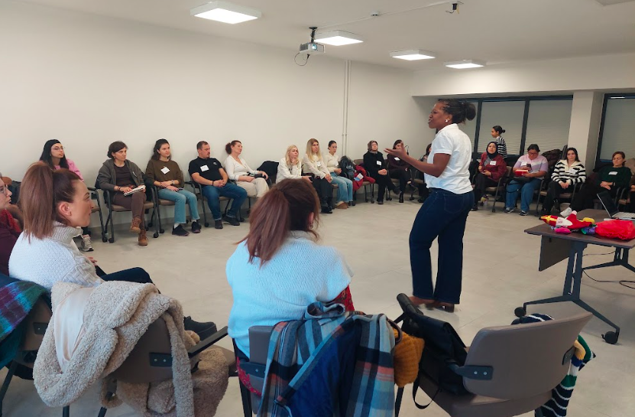
Figure 1. Facilitator leading an interactive whole-group session

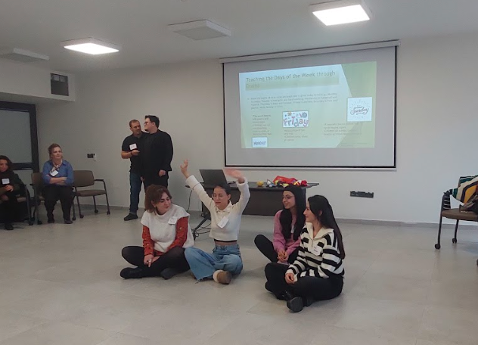 | 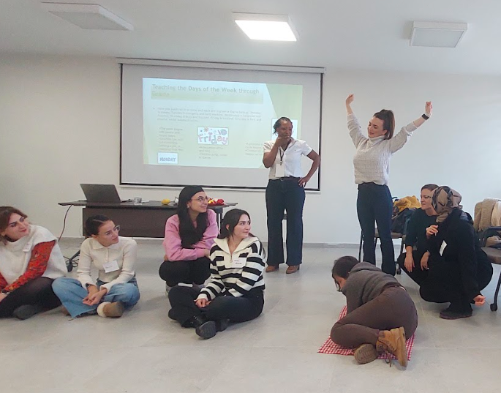
Figure 2 and 3. Storytelling and rhyme-based creative learning activity

Workshop 2 (Storytelling with Immigrant Children: Visual and Contextual Support) focused on the role of storytelling in supporting language development, identity formation, communication skills, and social-emotional development when working with immigrant children. During the workshop, participants were presented with practical examples of how storytelling can be enriched through visual and contextual support. Participants were actively engaged in the process through creative narration, role-playing, and book-based activities. Additionally, the workshop explored the potential of storytelling to create inclusive learning environments and support effective communication in plurilingual classrooms within the framework of the CLIL approach.

Table 5. Content and Instructional Methods of Workshop 2 – Storytelling with Immigrant Children (Visual and Contextual Support)
Phase | Content | Methods | Materials/ Tools
Introductions and welcomes | Introduction and background | Group game for introductions: Go in pairs, introduce each other to group with two things. Then do trust walk [instructions on slide] | PPT for me [my story]
Theoretical Input: Child’s Perspective & Aistear Wheel | Discuss storytelling to address the themes | Group discussion | Four themes and planning stories to suit
Theoretical Input with Practice-based Examples (CLIL) | - CLIL methods - 1 lesson example: https://youtu.be/TMczkrHeP7A  - Describe use of CLIL: https://camps.pixel-online.org/motivational-videos.php  https://youtu.be/HGoNCB612zY | Describe use of CLIL,  video-based input | CLIL Languages Video: https://camps.pixel-online.org/clil-based-educational-videos.php
Interactive Practice: Imagination & Story Building | Story bag | Story bag How it works:  - Fill a bag with objects familiar across cultures: spoon, toy animals, scarf, cup, rock, leaf, key.  - Each child pulls out 1 object and adds it to a collaborative story. | Bag and objects
Interactive Discussion: Types of Stories | - Imagination  - Books  - Props  - Mime  - Puppets  - Our own history | Group discussion on how to tell stories | Flipchart
Collaborative Activity: Our Origin Tree | Small groups create their story as a leaf, flower, on the tree, decorate with colours, feathers etc.  All plant their stories on the tree. | Group work | Markers
Practice with Storytelling Materials (Books) | - Handa’s Surprise  - Going on a bear hunt | Use fruit and dish, toy animals if available, volunteers select roles and act out | Books + props
Review Storytelling | Link to Aistear themes, CLIL | Group reflection | Finish with images of Logo Awards

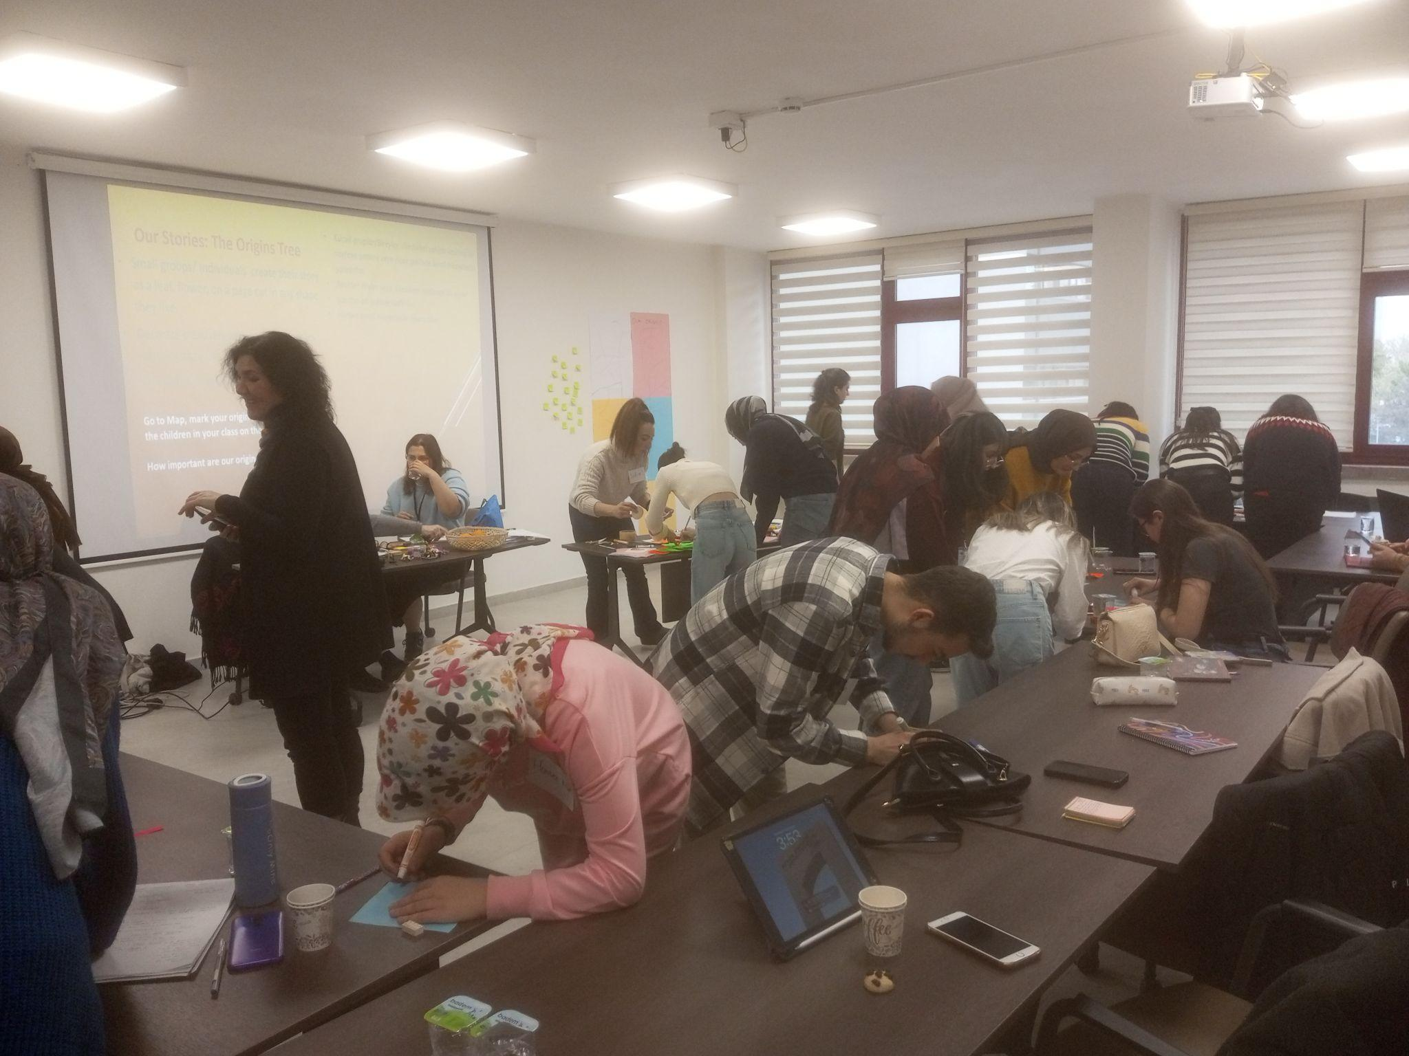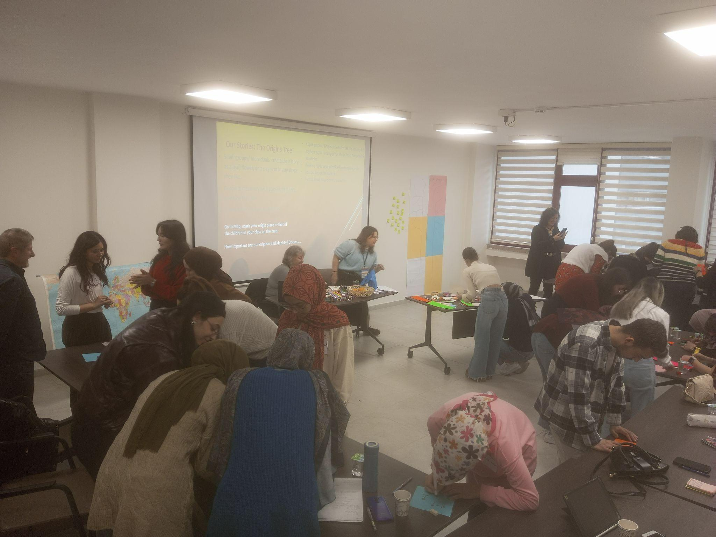 | 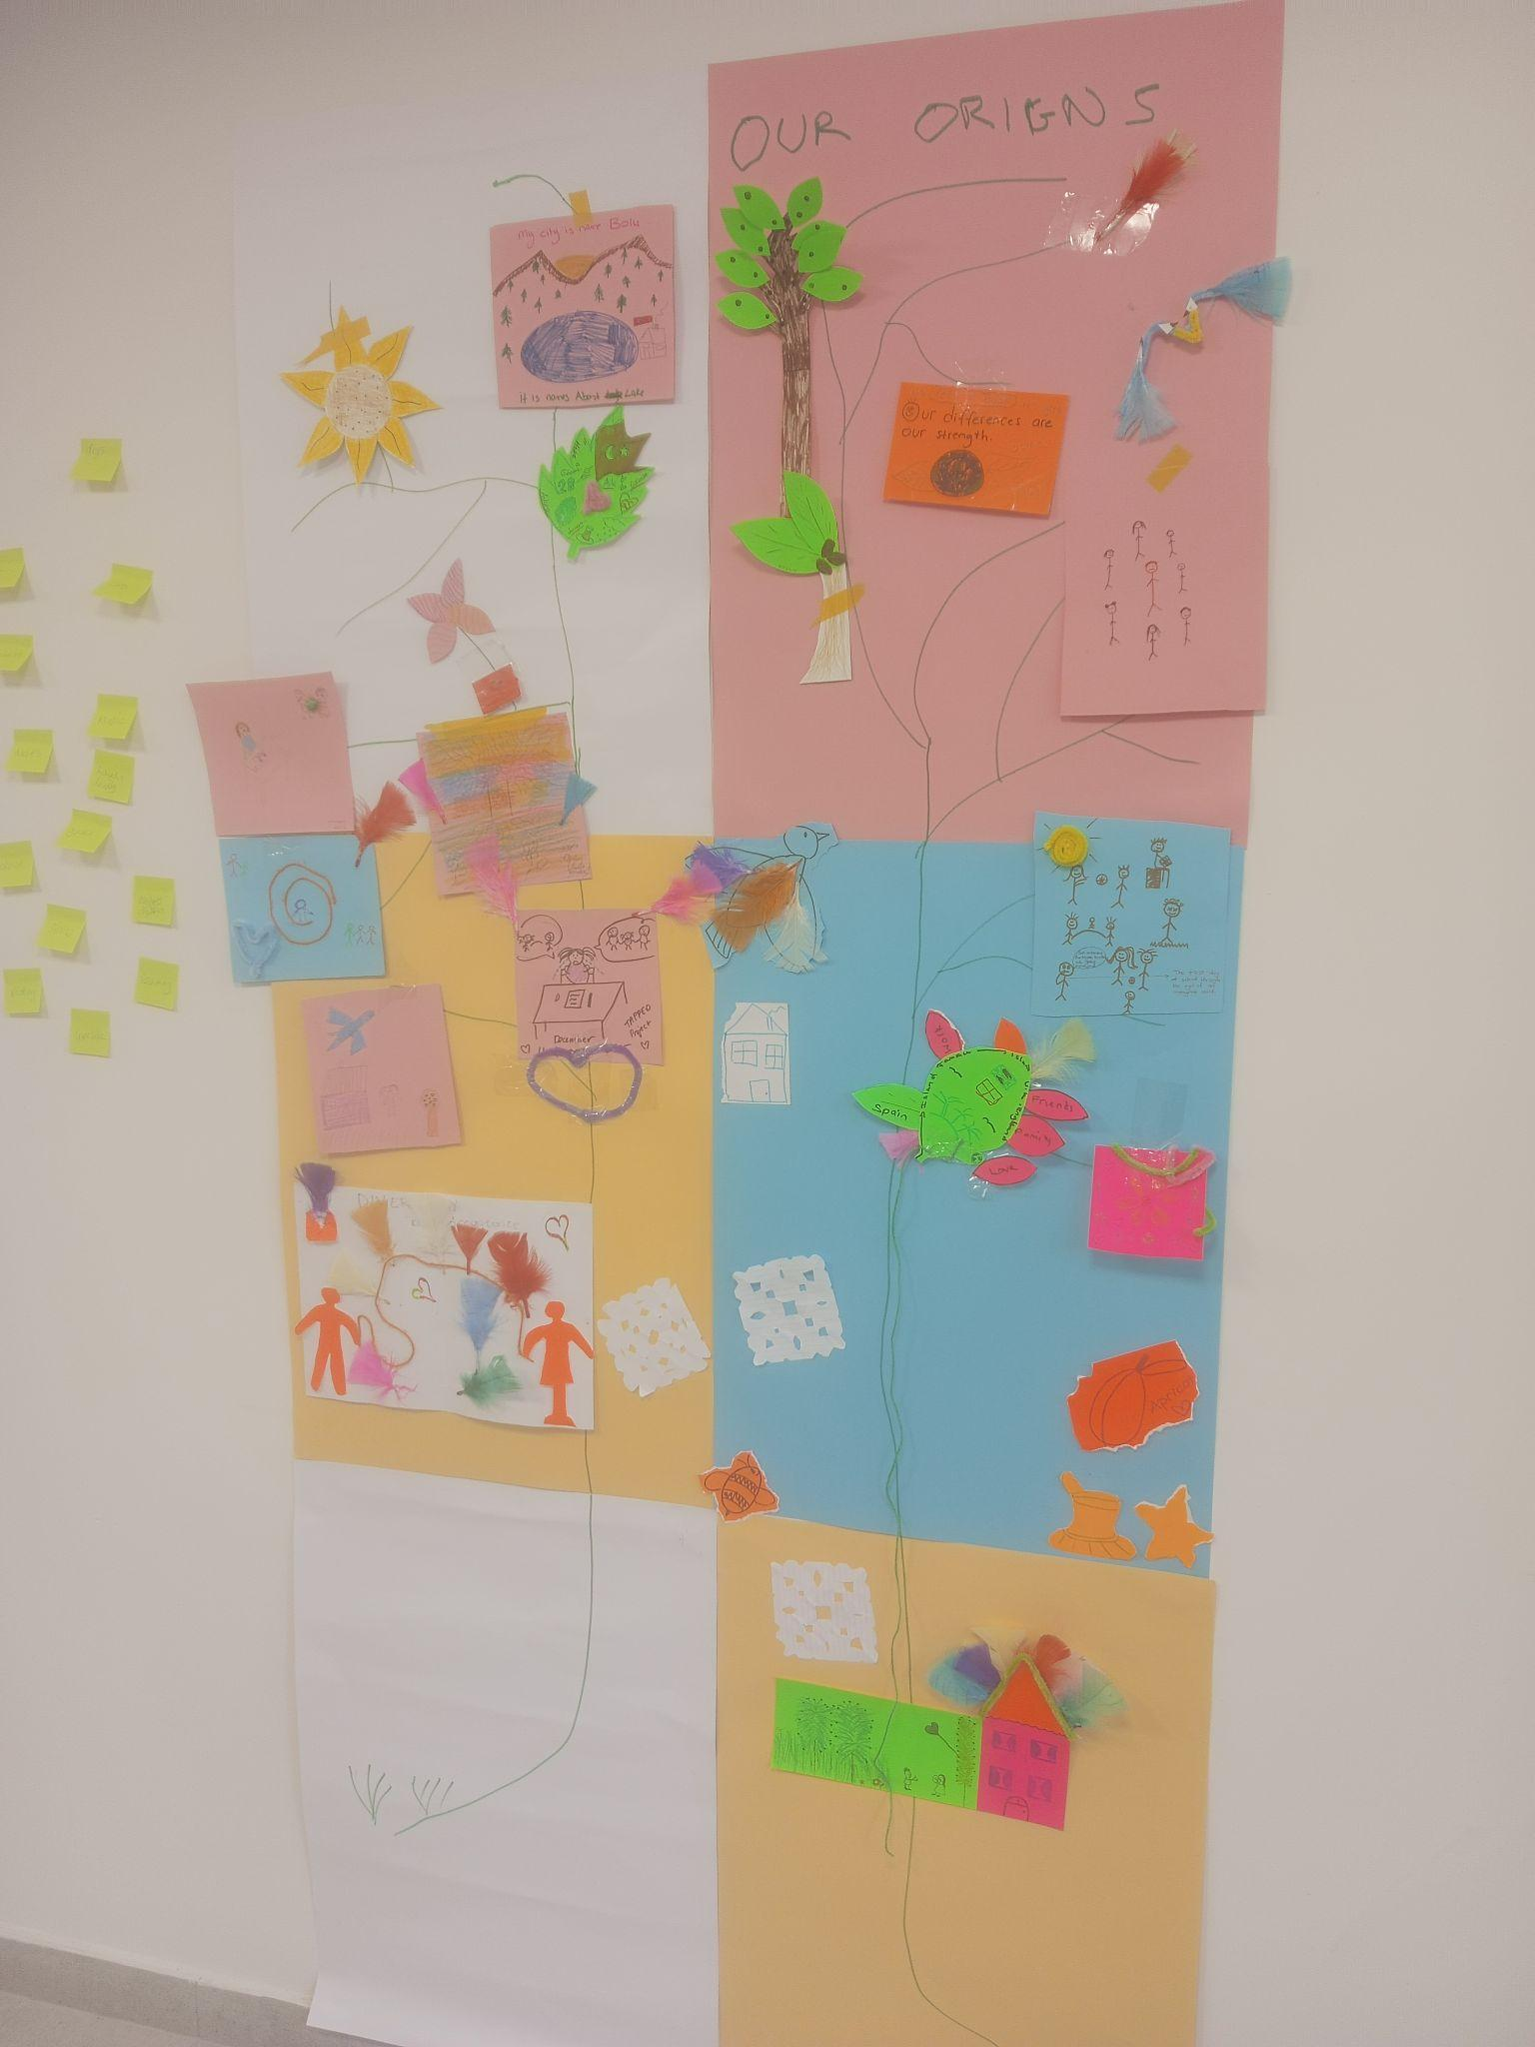
Figure 4, 5 and 6. Collaborative “Origin Tree” activity, where participants co-create and share their stories visually

Workshop 3 (Inclusive Language Games Through Migration-Themed Picture Books) focused on how picture books with a migration theme can be used as a pedagogical tool to design inclusive language learning activities in plurilingual classrooms. Within the scope of the workshop, participants were provided with a theoretical framework on inclusive pedagogy, plurilingual pedagogy, and language games; followed by practical examples of integrating picture books into language learning processes. Through station-based collaborative activities, participants engaged in creative learning tasks such as podcast production, inclusive language game design, and creating migration-themed picture books. The aim was for participants to gain experience in developing plurilingual and inclusive teaching practices and to connect theory with practice.

Table 6. Content and Instructional Methods of Workshop 3 – Inclusive Language Games Through Migration-Themed Picture Books
Phase | Content | Methods | Materials/ Tools
Warm-up and introduction | Ice-breaking activity: Ball game (name-country-favourite word) | Interactive group activity | Soft ball
Theoretical input with practice-based examples | - Inclusive pedagogy, plurilingual pedagogy, immersion, language games  - Characteristics and selection of migration-themed picture books  - Integration of picture books with inclusive language games: Examples of traditional and digital language games | Bilingual lecture | Bilingual slides
Break
Activity briefing and task guidelines | - Explanation of station-based collaborative activities (15 minutes per station, rotating groups)  - Clarification of collective product development and process-oriented learning across stations  - Assignment of station facilitators (one per station)  - Distribution of written bilingual task guidelines |  | Written bilingual task guidelines
Picture book reading and selection | - Shared reading of a migration-themed picture book in Turkish and English  - Viewing of a wordless picture books through a video  - Collective voting for one book | Bilingual read-aloud; video-based exploration of a wordless picture book | - Printed picture books (Ferris Wheel, Migrantes)  - Wordless picturebook video (Migrantes)
Station-based activities | - Station 1 - Podcast preparation: Preparation of a one-minute podcast inspired by the selected picture book. Reflective and expressive language use through digital storytelling.  - Station 2 - Inclusive language game design: Design of inclusive language games inspired by the selected picture book. Development of play-based and interactive activities helping children understand the theme of migration and foster empathy.  - Station 3 - Picture book creation: Creation of migration-themed picture books. Storytelling and visual expression supporting inclusive perspectives of migration. | Hands-on, station-based collaborative activities | - Written bilingual task guidelines  - Printed copy of the selected picture book  - Station specific materials (paper, cardboard, markers, scissors, glue, ribbons)  - Mobile phones (participants’ own devices) for audio recording and podcast production
Collective reflection and product sharing | - Sharing station-based products (podcasts, language games, picture books)  - Collective reflection on learning processes  - Linking theory to practice  - Peer learning and experience exchange | Collaborative reflection, peer sharing | Participant-created products (podcast, language games, picture books)
Guided individual reflection and workshop evaluation | - Individual mean-making  - Professional self-reflection  - Evaluation of workshop  - Feedback for future teacher training activities | Guided individual reflection, workshop evaluation | - Reflection form (paper-based)  - Workshop evaluation questionnaire (digital, accessed via QR code)

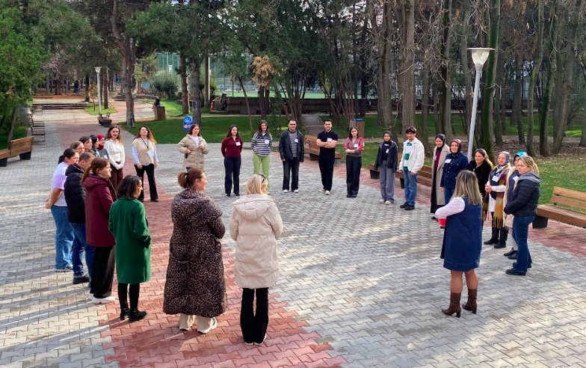
Figure 7. Ice-breaking ball game fostering interaction and group engagement

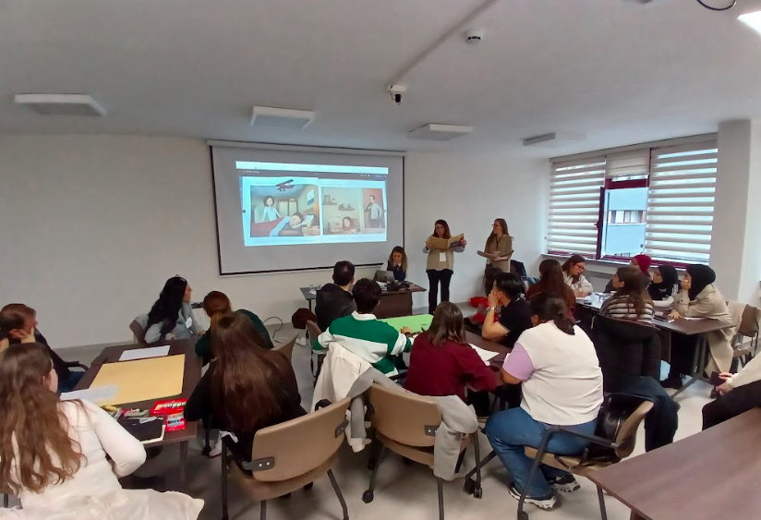
Figure 8. Bilingual picture book reading and collaborative selection activity

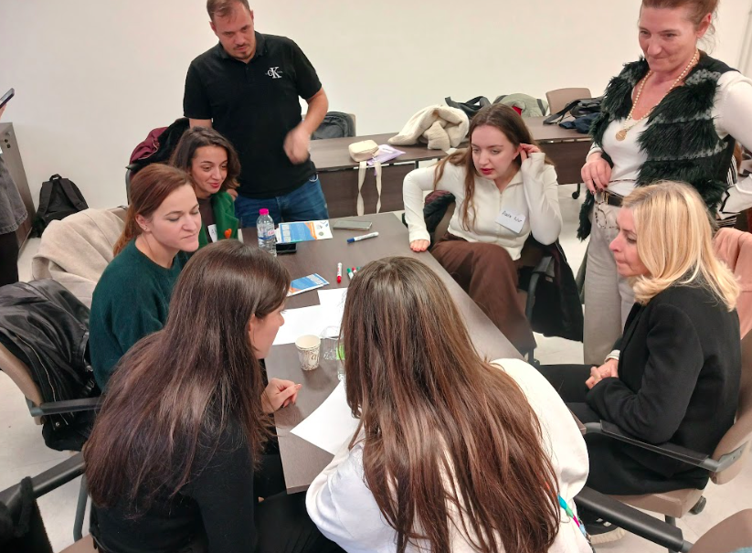 | 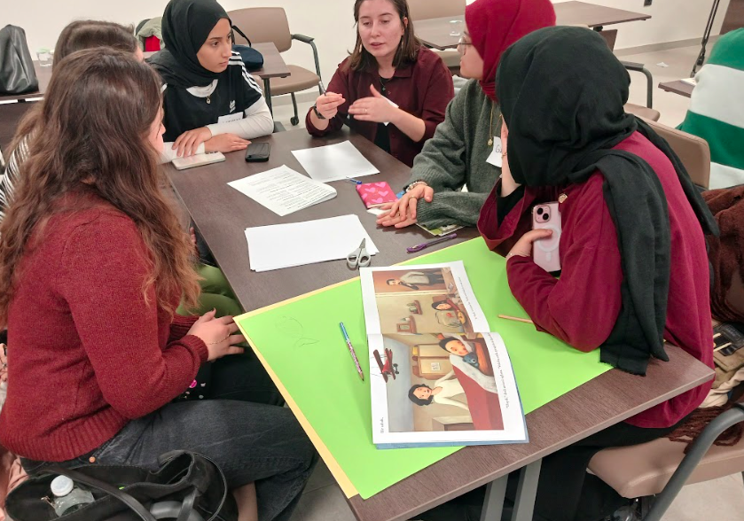
Figure 9 and 10. Hands-on, station-based collaborative learning activities

Workshop 4 (Creative Drama for Inclusion and Diversity in Multilingual Classrooms) focused on the impact of creative drama on inclusion, diversity, and social-emotional development in multilingual classrooms. During the workshop, participants were shown through hands-on activities how drama, role-playing, movement, and drama techniques can be integrated into the classroom setting. Participants were actively engaged in the process through group work, songs, and rhymes. They developed their pedagogical skills through activities adapted to different age groups and story-based drama examples. Additionally, the workshop addressed topics such as providing language support, encouraging children to use their home language, managing group dynamics, and planning inclusive practices within the classroom.

Table 7. Content and Instructional Methods of Workshop 4 – Creative Drama for Inclusion and Diversity in Plurilingual Classrooms
Phase | Content | Methods | Materials/ Tools
Introductions/ welcomes | My Intro/background | Group game for introductions:  - Go in pairs, introduce each other to group with two things.  - Then in pairs create a sculpture, others view each sculpture A | PPT for me [my story]
Theoretical Input: Drama and Child Development | - The Child’s Perspective  - Free Play and Role of play and play types  - Why Drama?  - Rationale for using drama: benefits, opportunities | Short exercise: what types did they play as a child | Slides
Practical Input: Using Drama in the Classroom | - Using drama in your classroom (when, how, who)  - Acting out from books, nursery rhymes: taking on roles | Small group discussions, record on flipchart | Flipchart, markers
Interactive Practice: Creating a Drama | Exercise:  1] Hand/body animals  2] Monster Tag  3] Sculpture Gallery  4] Mirroring | Guided activities and group participation:  - Prepare cards with animals drawn on, and in writing.  - Get 10 volunteers, draw card, create the animal all others guess the animal.  - The first guesser pairs up and at end they create a monster in pairs.  - Then in groups they create a monster. | Cards with animals, prepared cards
Practice with Nursery Rhymes | Simple Dramas from Nursery Rhymes Two Goats [Turkish Rhyme] | - Rhyme on slide.  - Volunteers to act out the rhyme, using props.  - Whole group support. | Slides, props
Group Work Preparation | Create Group Dramas Consider age groups | In 5 groups of 5/6 prepare acting out/ mime drama x 5 minutes: “Rooms in the house”  - Bring lego pieces in colours and a bag to select groups!  - List rooms on card and get groups to choose randomly  - Create their object from room, create tableaux of room in their group, others will view and name, taking turns  - 5 minutes to prepare  - NB Prepare cards | Lego pieces, bag, cards
Group Presentations | Present group dramas, each group present their drama to the others | Each group present silently and other groups take turns
Reflection and Analysis | Discuss language issues, how to support, how they managed, how did the preparation plan work | Large group discussion
Review session: most useful, what they will use | Review, discuss how they will use in the classroom… let children prepare in native language? Other ideas? Peer support/twinning
Babel Clip | Explain clip/use of drama | Video viewing | https://vimeo.com/209642276
End and evaluations | Wrap up | Group Closure

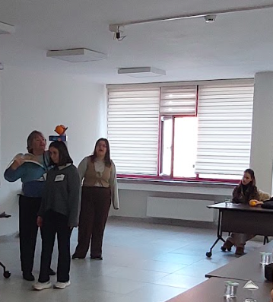 | 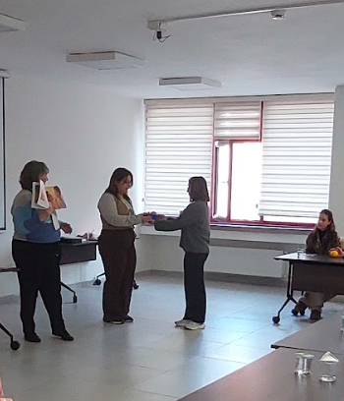
Figure 11 and 12. Participants engaging in a drama-based activity

Workshop 5 (Inclusive Language Integration Techniques in Preschool) focused on inclusive language integration strategies in the context of early childhood education. Within the scope of the workshop, participants were introduced to the basic principles of early language acquisition and pedagogical approaches that support language development in multilingual learning environments. Following the theoretical framework, participants examined and practiced practical examples of inclusive language teaching through TPR (Total Physical Response)-based activities, gamification, and interactive classroom activities. Furthermore, through collaborative work processes, participants had the opportunity to develop their own inclusive activity designs and experience how to transfer these approaches to classroom practices.

Table 8. Content and Instructional Methods of Workshop 5 – Inclusive Language Integration Techniques in Preschool
Phase | Content | Methods | Materials/ Tools
Presentation of the workshop | Initial greeting activity  Workshop objectives | Student interaction  Oral presentation | PPT
Theoretical foundations | Language acquisition essentials | Oral presentation, cooperative groups | PPT,  group debate
Development | TPR and interactive activities | Gamification | Video
Implementation | Word pot activity | Gamification, team work | Cards, pencils
Autonomous work | Inclusive activity design | Cooperative learning | Sheets,pens

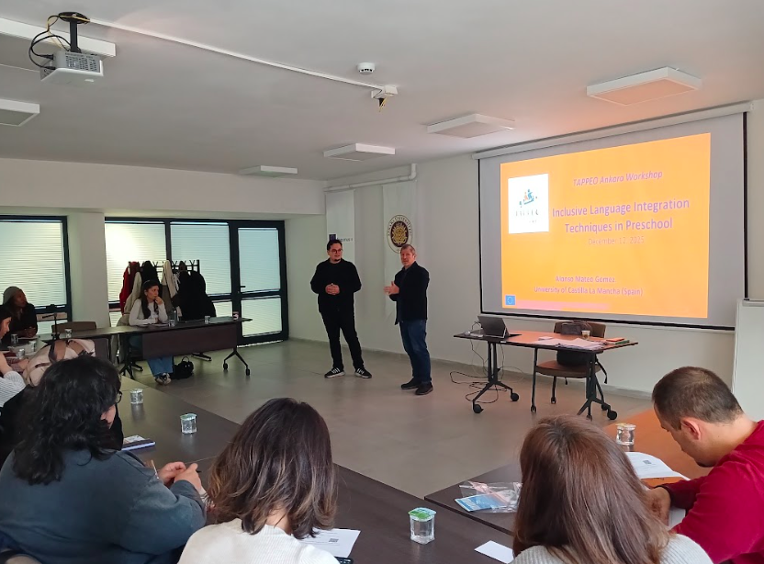
Figure 13. Facilitator presenting workshop content and guiding participants through immersive language activities

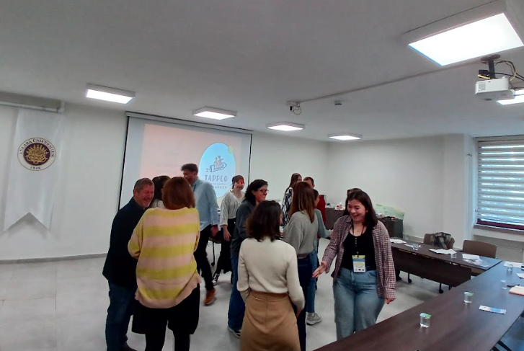 | 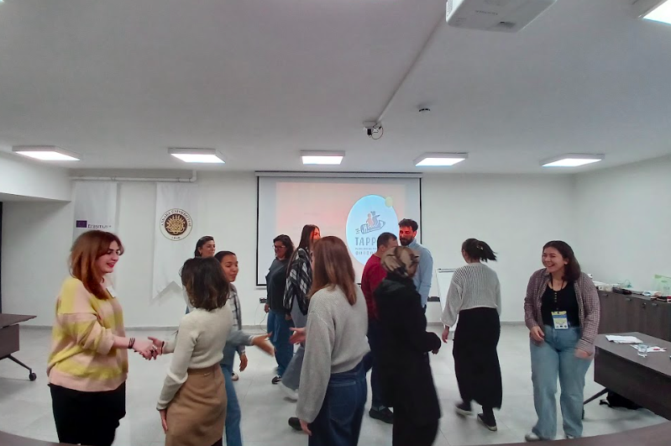
Figure 14 and 15. Ice-breaker activity encouraging participant interaction and collaboration

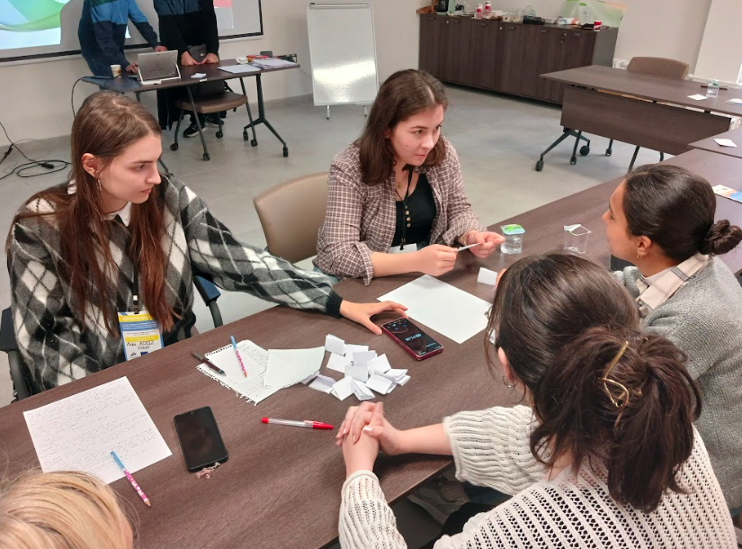 | 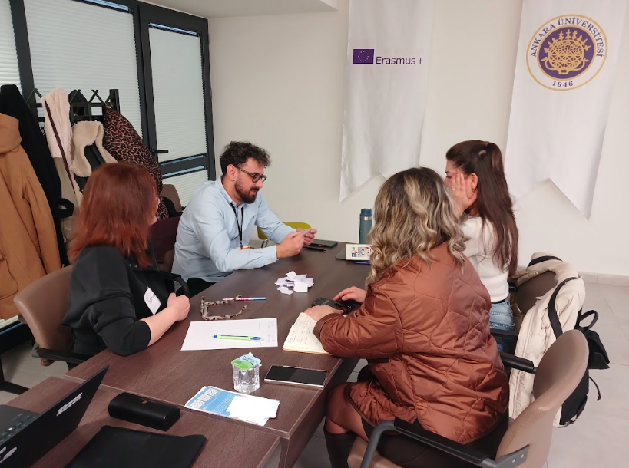
Figure 16 and 17. Team-based Word Pot activity encouraging gamified, interactive language learning

The seminar (Together in Learning: Empowering Parental Involvement in Plurilingual Classrooms) aimed to introduce participants to an inclusive and plurilingual pedagogy focused on strengthening family involvement in the learning processes of children from migrant backgrounds. During the seminar, participants learned the core principles and implementation strategies of the Plurilingual Notebook project. They had the opportunity to enrich their pedagogical approaches through examples such as collaboration with families, the design of multilingual activities, and the use of digital/AI tools. Participants also developed skills to design, implement, and evaluate similar projects within their own contexts. They explored ways to critically assess their own practices within the framework of professional responsibility and autonomy, and to utilize ongoing collaboration with colleagues as a structured learning process.

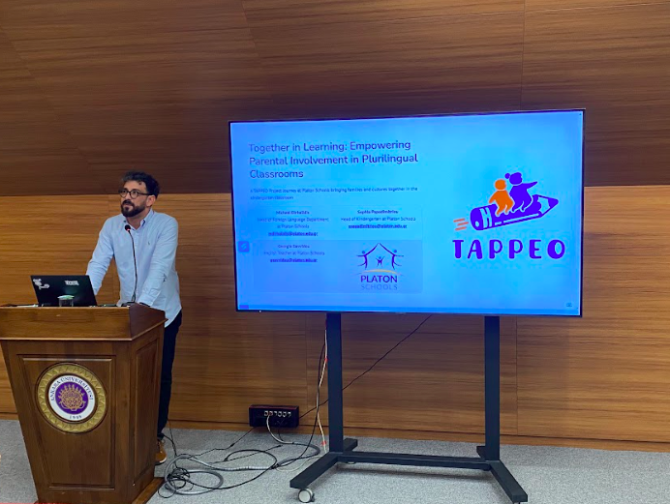
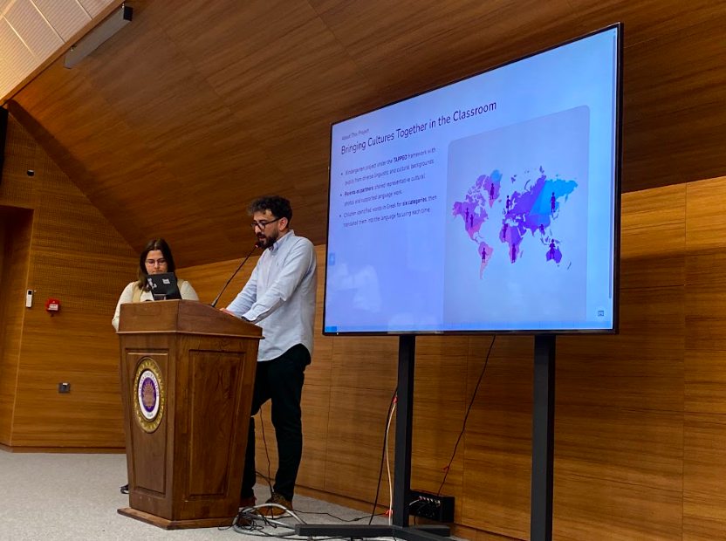
Figure 18 and 19. Seminar session on strengthening parental engagement in plurilingual classrooms

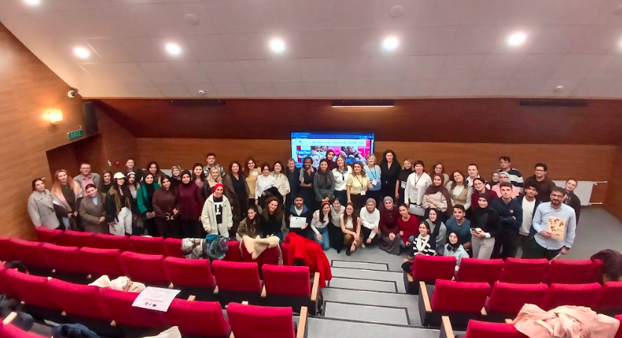
Figure 20. Group photo of seminar participants

6. Evaluation of the Teacher Training

6.1. Evaluation design and instrument

An evaluation process was conducted to assess the effectiveness of the teacher training programme, participant experiences, and its contribution to professional learning. Within this scope, a form was created to evaluate participant satisfaction, learning experiences, sense of professional self-efficacy, and future professional learning needs. The evaluation tool was administered to participants at the end of each training session on a voluntary basis. This process enabled participants to provide direct feedback on their training experiences and allowed for an assessment of the training programme.

6.2. Participants
To evaluate the training programme, participants were asked to complete an evaluation survey at the end of each training session. Following six training sessions with a total of 178 participants, 90 responses were received. This number corresponds to a response rate of 50.6% of the total number of participants who attended all training sessions. Since participants could attend more than one training session, they completed a separate questionnaire after each session. Therefore, the analyses were conducted at the level of responses rather than at the individual level, and the reported numbers represent the number of completed evaluation forms rather than the number of unique participants. 24.4% of the survey responses came from in-service teachers (n=22), while 75.6% came from teacher candidates (n=68). This distribution provides insight into how the training programme was evaluated by both teachers and teacher candidates.
The demographic and professional profile of teachers who responded to the survey is presented in Table 10. According to the questionnaire responses, all teachers were female, and the vast majority had received training in areas related to early childhood and primary education, such as child development, preschool teaching, and classroom teaching. The responses indicate that the majority of teachers have many years of professional experience and work primarily in private preschools, especially with children aged 5–6. Furthermore, while approximately half of the responses indicate that teachers have children who speak different languages in their classrooms, it appears that only a limited number have received any previous professional training in plurilingual education.
Table 10. Profile of Teacher Questionnaire Respondents (n=22)
Gender | Female  Male  Other/ Prefer not to say | 22  -  - | 100%  -  -
Field of Study | Child Development / Child Development and Education / Learning and Development | 9 | 40.9%
Field of Study | Early Childhood Education | 7 | 31.8%
Field of Study | Primary Education | 3 | 13.6%
Field of Study | English Literature | 2 | 9.1%
Field of Study | Secondary Education | 1 | 4.5%
Teaching Experience | Less than 1 year | 1 | 4.5%
Teaching Experience | 1-5 years | 3 | 13.6%
Teaching Experience | 6-10 years | - | -
Teaching Experience | 11-15 years | 3 | 13.6%
Teaching Experience | 16-20 years | 13 | 59.1%
Teaching Experience | More than 20 years | 2 | 9.1%
Type of School | Public school | 5 | 27.3%
Type of School | Private school | 16 | 68.2%
Type of School | Other | 1 | 4.5%
School Level | Preschool | 16 | 72.7%
School Level | Primary School | 6 | 27.3%
Age Group Taught | 3-4 years | 2 | 9.1%
Age Group Taught | 4-5 years | 3 | 13.6%
Age Group Taught | 5-6 years | 9 | 40.9%
Age Group Taught | 6-7 years | 5 | 22.7%
Age Group Taught | Mixed-age group | 3 | 13.6%
Multilingual Learners in Classroom | Yes | 11 | 50%
Multilingual Learners in Classroom | No | 11 | 50%
Prior Training in Multilingual Education | Yes | 3 | 13.6%
Prior Training in Multilingual Education | No | 19 | 86.4%

The characteristics of teacher candidates who responded to the survey is presented in Table 11. According to the questionnaire responses, the majority of teacher candidates are female and are primarily enrolled in preschool and primary teaching programmes. The responses also indicate that the majority of teacher candidates are in their second and third years of undergraduate programmes and that only a limited number have student teaching experience. The findings also show that many teacher candidates have not taken any courses on plurilingual education, have not participated in professional learning opportunities such as seminars or workshops in this topic, and have very limited experience working directly with plurilingual learners.

Table 11. Profile of Teacher Candidate Questionnaire Respondents (n=68)
Gender | Female | 56 | 82.4%
Gender | Male | 11 | 16.2%
Gender | Other/ Prefer not to say | 1 | 1.5%
Programme | Early childhood education | 41 | 60.3%
Programme | Primary education | 16 | 23.5%
Programme | Psychological counseling and guidance | 6 | 8.8%
Programme | English language teaching | 1 | 1.5%
Programme | Educational psychology | 1 | 1.5%
Years of Study | 1st year | 6 | 8.8%
Years of Study | 2nd year | 25 | 36.8%
Years of Study | 3rd year | 23 | 33.8%
Years of Study | 4th year | 13 | 19.1%
Years of Study | Graduate student (MA) | 1 | 1.5%
Teaching Practicum Experience | Yes | 17 | 25%
Teaching Practicum Experience | No | 51 | 75%
Coursework related to Multilingual Education | Yes | 14 | 20.6%
Coursework related to Multilingual Education | No | 54 | 79.4%
Prior Training on Multilingual Education (Seminar/ Workshop) | Yes | 5 | 70.4%
Prior Training on Multilingual Education (Seminar/ Workshop) | No | 63 | 92.6%
Prior experience with multilingual learners (e.g. volunteering) | Yes | 2 | 2.9%
 | No | 62 | 91.2%
 | Limited/Informal experience | 4 | 5.9%

6.3. Evaluation results

6.3.1. Overall satisfaction
Findings related to the workshops indicate that participants’ satisfaction levels were generally high. The vast majority of participants stated that the workshop content was consistent with the objectives and that the theoretical content and practical examples provided were sufficient and supportive. In particular, the facilitators’ guidance, opportunities for active participation, and practical examples were among the most highly rated aspects. Examples related to the use of digital and artificial intelligence tools were rated lower than other items, but still positively.
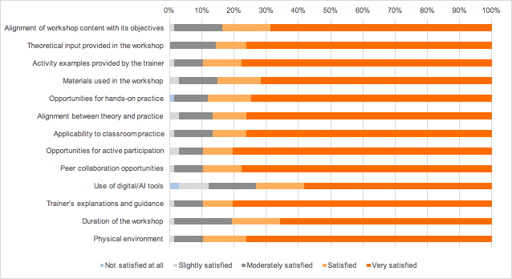
Figure 21. Overall distribution of participant satisfaction ratings for the teacher training workshops (n = 67)
Findings related to the seminar also indicate a high level of satisfaction overall. Participants largely evaluated the seminar content's alignment with objectives, theoretical content, and practical examples positively. Practical examples stood out as a particular strength. However, active participation and peer interaction received more limited evaluations compared to workshops.
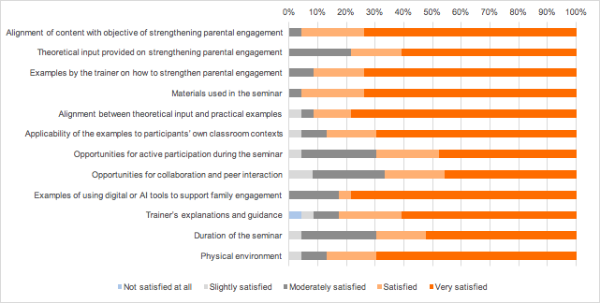
Figure 22. Overall distribution of participant satisfaction ratings for the teacher training seminar (n = 67)

6.3.2. Sense of professional self-Efficacy

Findings regarding sense of professional efficacy in workshops indicate that a large percentage of participants felt more competent after the training. Participants’ sense of efficacy was particularly high in areas such as developing practical knowledge and skills, and planning and implementing related activities. However, the fact that some participants rated themselves as moderately competent suggests that more opportunities for practice and supportive training in these areas could further strengthen their self-efficacy perceptions.

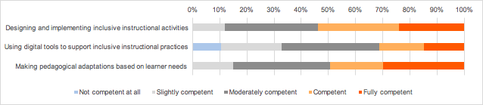
Figure 23. Participants’ perceived competence after the teacher training workshops (n = 67)

The findings related to the seminar also show that a significant portion of the participants rated themselves as competent. This indicates that the seminar supported their perception of professional competence. However, the fact that some participants rated their self-efficacy as moderate suggests that supporting theoretical knowledge with practical application could further strengthen their perception of self-efficacy.

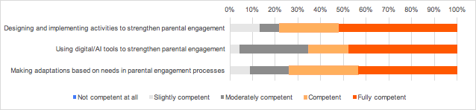
Figure 24. Participants’ perceived competence after the teacher training seminar (n = 67)

6.3.3. Learning Experiences
Findings on the learning experiences related to the workshops show that the vast majority of participants responded to the items at the “agree” and “strongly agree” levels. Particularly noteworthy are the high levels of positive evaluations in the areas of increased awareness, opportunities for practice, and pedagogical reflection. The small number of negative responses indicate that the workshops were perceived by participants as an effective and supportive learning environment. The findings indicate that, despite differences in content, the workshops generally provided positive learning experiences.

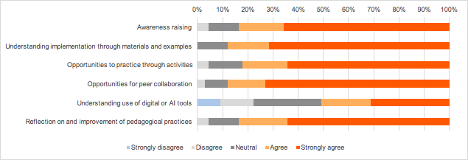
Figure 25. Participants’ learning experiences in the teacher training workshops (n = 67)
Findings regarding the learning experiences related to the seminar also show a similarly positive distribution. A significant portion of participants stated that the seminar increased their awareness (60.9% “strongly agree”) and that the materials and examples used contributed to their understanding of the practice (60.9% “strongly agree”). Highly positive responses were also observed regarding the use of digital/artificial intelligence tools and the pedagogical reflection dimension. The low level of negative responses indicates that the seminar offered a generally satisfying structure in terms of the learning experiences.
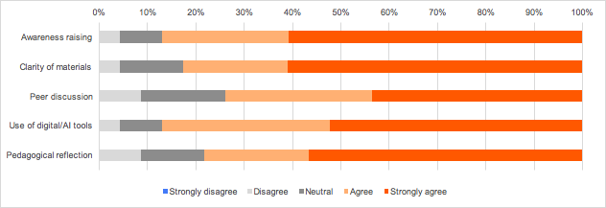
Figure 26. Participants’ learning experiences in the teacher training workshops (n = 67)

6.3.4. Future Learning Needs
The findings indicate that the vast majority of participants continue to have professional development needs related to inclusive and plurilingual pedagogy. The most frequently cited needs were seeing more examples of activities (71.6%), adapting activities to different age groups (67.2%), and selecting appropriate materials (62.7%). More than half of the participants also indicated that they needed more opportunities to practice (%58.2). In contrast, the demand for additional support in using digital or artificial intelligence tools was more limited (%28.4). Only a small proportion of participants (%16.4) stated that they did not need additional professional learning. These results highlight the importance of practice-based, example-focused professional development opportunities that focus on developing adaptation skills.

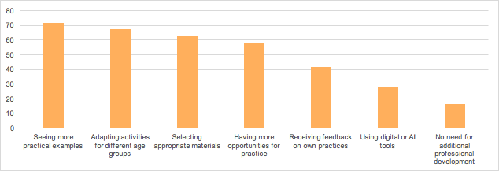
Figure 27. Participants’ Additional Professional Development Needs Identified After the Workshops (Multiple Responses Allowed, n = 67)

The most frequently mentioned professional development need expressed by participants after the seminar was seeing more examples of activities aimed at strengthening parent engagement (60.9%). Approximately half of the participants indicated that they wanted to improve themselves in the areas of using inclusive strategies (52.2%), using digital or artificial intelligence tools (52.2%), and doing more practice (47.8%). The need for appropriate material selection (43.5%) and receiving feedback on their own practices (30.4%) also stood out. Approximately one-third of participants (30.4%) stated that they did not need additional professional development in this area. These findings show that the seminar raised awareness but that there is still a need for more support, particularly in terms of practice, examples, and the use of digital tools.

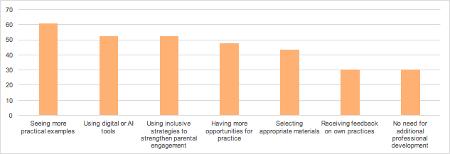
Figure 28. Participants’ Additional Professional Development Needs Identified After the Seminar (Multiple Responses Allowed, n = 67)

7. Conclusion
The TAPPEO Teacher Training Programme was planned as a two-day face-to-face event held on December 11–12, 2025, at Ankara University’s Main Campus. A total of 178 teachers and teacher candidates participated in the programme. Coming from different countries and educational contexts, the participants created a multilingual and culturally diverse learning environment. The programme included five workshops and one seminar. The sessions were conducted in both Turkish and English, with interpretation provided for some sessions.

The programme’s workshops covered various pedagogical areas, including creative expression through music and drama, language engagement through migration-themed stories and picture books, game-based language learning activities, and inclusive language integration. The seminar session, meanwhile, focused on strengthening family participation and adapting initiatives like the Plurilingual Notebook project to local contexts. This structure ensured that teachers were equipped with both theoretical knowledge and practical tools.

The programme has successfully bridged the gap between theoretical knowledge and classroom practice by providing a practice-oriented, reflective, and collaborative learning environment for teachers and teacher candidates. Pedagogical methods such as drama, music, game-based learning, and storytelling have been effectively utilized as tools to support language participation and strengthen children’s social-emotional development. Through the training sessions, participants developed their knowledge and skills in inclusive pedagogy and plurilingual pedagogy, creating concrete tools and activities they can implement in their own classroom settings. The seminar, meanwhile, provided opportunities to strengthen parental engagement, support school-parent collaboration, and adapt project-based pedagogical practices to their own contexts.

According to participants’ evaluations, the programme generally received a high level of satisfaction. Most participants reported that they had increased their professional self-efficacy, developed their pedagogical knowledge and skills, and can apply what they learned to their own classroom practices. Key outcomes included the following:

- Knowledge: Enhanced understanding and insight into inclusive pedagogy, plurilingual pedagogy, and immersive language experiences in early childhood.
- Skills: The ability to apply pedagogical methods such as drama, music, play, and storytelling in the classroom; and the ability to use digital and AI tools appropriately.
- Responsibility and Autonomy: The ability to plan and manage one’s own teaching processes, sustain professional learning, participate in collaborative professional learning processes, and engage in continuous self-assessment.

The programme has enabled teachers and teacher candidates to develop concrete tools and activities that allow them to implement inclusive, multilingual, and experience-based pedagogy in their classrooms. Additionally, the reflective and collective discussions held throughout the educational process have supported participants in making pedagogical decisions with greater awareness and contextual sensitivity.

In addition, participant feedback has identified areas of learning that will continue to be needed in the future. In particular, additional training needs have been identified regarding the use of advanced digital and AI tools in plurilingual and inclusive classroom settings, the diversification of in-class experiences, and effective collaboration with families. The TAPPEO project will continue to support teachers’ ongoing professional development by refining the current educational model and designing new learning sessions to address these needs. The goal is to both strengthen participants’ current pedagogical skills and enhance equity and inclusivity in early childhood education.

8. References

Cenoz, J., & Gorter, D. (2022). Pedagogical translanguaging. Cambridge University Press.

Darling-Hammond, L., & Oakes, J. (2019). Preparing teachers for deeper learning. Harvard Education Press.

European Commission. (2023). Promoting diversity and inclusion in schools in Europe. Publications Office of the European Union.

European Commission. (2025). Key data on early childhood education and care in Europe 2025 – Eurydice report. Publications Office of the European Union.

Florian, L. (2015). Inclusive Pedagogy: A transformative approach to individual differences but can it help reduce educational inequalities? Scottish Educational Review 47(1), 5–14.

Fortune, T. W., & Tedick, D. J. (Eds.). (2020). Immersion education: Practices, policies, and challenges. Multilingual Matters.

García, O., & Wei, L. (2014). Translanguaging: Language, bilingualism and education. Palgrave Macmillan.

Grossman, P., Hammerness, K., & McDonald, M. (2009). Redefining teaching, re‐imagining teacher education. Teachers and Teaching: Theory and Practice, 15(2), 273–289.

OECD. (2025). Reducing inequalities by investing in early childhood education and care: Starting strong. OECD Publishing.

Vescio, V., Ross, D., & Adams, A. (2008). A review of research on the impact of professional learning communities on teaching practice and student learning. Teaching and Teacher Education, 24, 80–91.

Zeichner K. M., & Liston, D. P. (2014). Reflective teaching: An introduction (2nd ed). Routledge.

